United Nations Industrial Development Committee
Analyzing the Global Adoption of Clean Technology and Its Impact on Economic Growth and Societal Acceptance: A Holistic Examination of the Benefits and Challenges

Contents

General Information: United Nations Industrial Development Committee (UNIDO) 4
I. Historical Background 4
II. Current Aim 4
III. Funding 5
IV. Sustainable Development Goals & Millennium Development Goals 6
Analyzing the Global Adoption of Clean Technology and Its Impact on Economic Growth and Societal Acceptance: A Holistic Examination of the Benefits and Challenges 9
I. Introduction 9
II. Definition of Key Terms 10
III. Current Situation 11
IV. Impact on Economic Growth and Societal Acceptance 14
V. Benefits and Challenges 23
VI. Relevant UN Treaties and Campaigns 25
VII. Previous Attempts to Solve the Issue 27
VIII. Possible Solutions 28
IX. Questions to be Answered 30
X. Bibliography 31

Letter from the Secretary-General

Most distinguished participants and dearest guests,
I am delighted to welcome you to the HASMUN’24 Conference of Kadir
Has University as the Secretary-General. Your participation and unique
perspectives will contribute to the success of this event.
With 8 diverse committees, each crafted to address the urgent need
forsolutions across a broad spectrum of specializations, we're set for
impactful discussions and innovative ideas. With our special 15th year of
Kadir Has University Model United Nations Club celebration, our
committees are:

• United Nations Office of Counter-Terrorism (UNOCT)
• International Atomic Energy Agency (IAEA)
• United Nations Population Fund (UNFPA)
• United Nations Industrial Development Organization (UNIDO)
• United Nations Office for Outer Space Affairs (UNOOSA)
• World Food Programme (WFP)
• International Monetary Fund (IMF)
• Historical Crisis Committee (HCC)

We, as the HASMUN'24 team, have made marvelous efforts to serve you,
participants, one of the greatest Model United Nations Conferences.
I want to conclude my words by thanking everyone involved in the
Academicand Organization teams for their greatest work. Delegates, I look
forward to your valuable contributions and meeting you in person.

#welcomehome
Best regards,
Aylin Rassad
Secretary-General HASMUN'24

Letter from the Chairboard

Dear Delegates,

We would very much like to welcome you all to the 10th edition of the Kadir Has University Model United Nations Conference. We consider it an honor to serve you as the Chairboard of the United Nations Industrial Development Committee in HASMUN’24, and we are especially excited to meet each and every one of you.

Our goal is to simulate a debate in the diplomatic atmosphere of the United Nations, Hence we are expected to abide by the rules of procedure and diplomatic etiquette. It is advised for each delegate to comprehensively study the rules of procedure.

As the representatives of your nations at the UNIDO Committee, you are expected to study and understand the following sections of this guide and conduct further elaborate research on the position and interests that might be relevant to the nations you represent for engaging in an abundant debate.

We are thrilled to see your contributions and insights during the sessions and hope you enjoy this committee and conference.

Best Regards,

Chairboard of The United Nations Industrial Development Committee,

General Information: United Nations Industrial Development Committee (UNIDO)

Historical Background

The United Nations Industrial Development Organization (UNIDO) was established in 1966 to support the industrial development activities of developing countries. The organization became a specialized agency of the UN in 1986 and is headquartered in Vienna, the capital of Austria. UNIDO's main aim is to contribute to the strong industrialization of developing countries. In recent years, UNIDO has taken on an increasingly stronger role in global development, focusing on environmental sustainability, comprehensive globalization and worldwide poverty reduction activities. With the Lima Declaration adopted at the 15th General Conference held in Lima / Peru in 2013, it was decided that the main task of the Organization was to ensure "Inclusive and Sustainable Industrial Development" in UNIDO member countries.

As of 2023, 172 countries are members of UNIDO. The highest administrative body of the organization is the General Conference, which is held every two years, the last of which was held in December 2023. The General Conference, convened with the participation of member countries, determines UNIDO's strategy and policies to be followed and approves the work program and budget. Other administrative bodies are Industrial Development Board 53; The Program and Budget Board consists of 27 members (Republic of Türkiye Ministry of Foreign Affairs, 2022).

Current Aim

The basic goal of UNIDO is to promote and accelerate long-term industrial growth in developing nations and economies in transition. Using its combined global resources and experience, the Organization seeks to improve the quality of life in the world's poorest nations. UNIDO's activity is divided into three topic areas: poverty reduction through productive activities, trade capacity building, and energy and the environment. Its help is based on two basic functions: as a global platform for the generation and dissemination of industry-related information, and as a source of technical support and cooperation (“UNIDO & MDG,” 2010).

Funding

UNIDO has 172 Member States, which provide assessed contributions to fund a regular budget for the Organization’s administration, research and other regular expenses. Member State representatives approve the budget and work programme and guide the principles and policies of the Organization. UNIDO implements projects and programmes in around 120 of its Member States. In 2023, UNIDO is implementing a portfolio of 636 projects with a total value of US$1,350m.

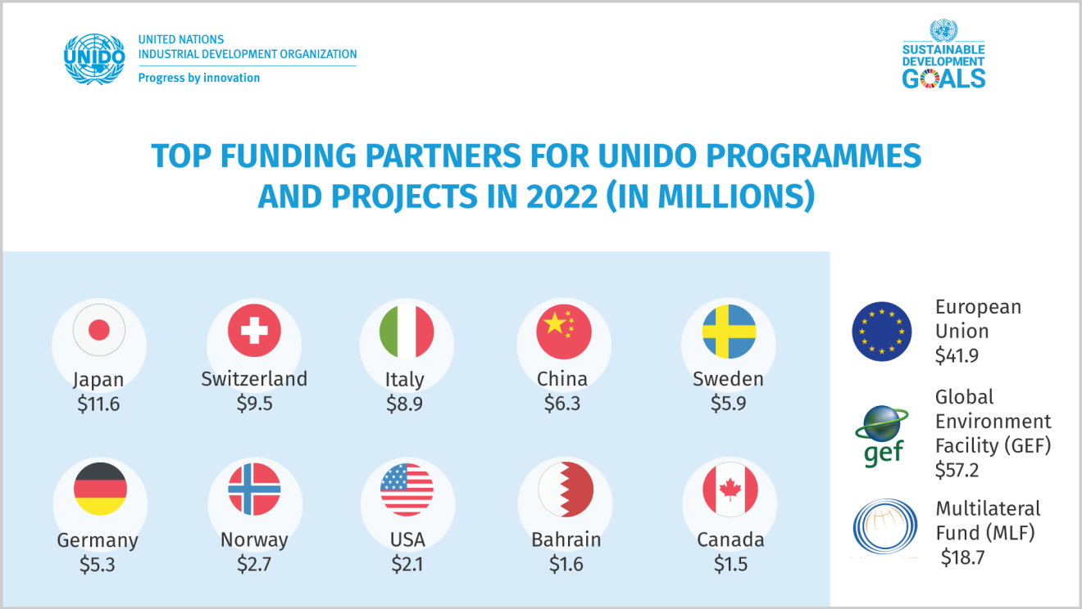
Source: United Nations Industrial Development Organization (2022)

UNIDO works in partnership with many organizations in the UN system, for example, the Food and Agriculture Organization (FAO) on agricultural trade development and the United Nations Environment Program (UNEP) in the Partnership for Action on Green Economy (PAGE). Additionally, UNIDO has strong relations with the BRICS+ group, consisting of five major developing economies, and the Group of 77 (G77), the largest intergovernmental organization of developing countries in the United Nations.

Apart from the aforementioned organizations, UNIDO maintains a strong relationship with the G20 as an officially recognized knowledge partner, providing expertise in various working groups and high-level ministerial meetings. UNIDO, with the support of the European Union (EU), actively assists Member States by providing technical cooperation in various fields. A shared vision has translated into tangible benefits in more than 100 countries in Africa, Asia and the Pacific, Latin America and the Caribbean, and the European Neighbourhood.

The latest UNIDO-Global Environment Facility (GEF) portfolio addresses key environmental problems, including industrial decarbonization, implementation and deployment of green hydrogen technologies, green chemistry innovation, and innovative and realistic investment models for climate change adaptation solutions. The longstanding cooperation with the Multilateral Fund for the Implementation of the Montreal Protocol remains strong, with UNIDO's Montreal Protocol Division currently working on the phase-out of hydrochlorofluorocarbons (HCFCs) and phase-down of hydrofluorocarbons (HFCs) in about 70 countries (United Nations Industısal Development Organisation, 2023).

Sustainable Development Goals & Millennium Development Goals

The United Nations approved the Sustainable Development Goals (SDGs), also known as the Global Goals, in 2015 as a global call to action to eradicate poverty, safeguard the environment, and ensure that by 2030, all people live in peace and flourish.

The 17 SDGs are interconnected, recognizing that actions in one area have an impact on results in others, and that development must strike a balance between social, economic, and environmental sustainability. Countries have pledged to prioritize improvement for those who are far behind. The SDGs are intended to eradicate poverty, hunger, AIDS, and discrimination against women and girls. The creativity, know-how, technology, and financial resources of the entire society are required to realize the SDGs in every situation (Sustainable Development Goals, n.d.).
Sustainable Developmental Goal 9 is what we are focusing on since UNIDO’s main goal is essentially SDG 9. Goal 9’s main aim is to build resilient infrastructure, promote inclusive and sustainable industrialization, and foster innovation. Goal 9 is explained further in the following points:

- 9.1 Develop quality, reliable, sustainable, and resilient infrastructure, including regional and transborder infrastructure, to support economic development and human well-being, with a focus on affordable and equitable access for all.
- 9.2 Promote inclusive and sustainable industrialization and, by 2030, significantly raise the industry’s share of employment and gross domestic product, in line with national circumstances, and double its share in least developed countries.
- 9.3 Increase the access of small-scale industrial and other enterprises, in particular in developing countries, to financial services, including affordable credit, and their integration into value chains and markets.
- 9.4 By 2030, upgrade infrastructure and retrofit industries to make them sustainable, with increased resource-use efficiency and greater adoption of clean and environmentally sound technologies and industrial processes, with all countries taking action in accordance with their respective capabilities.
- 9.5 Enhance scientific research, upgrade the technological capabilities of industrial sectors in all countries, in particular developing countries, including, by 2030, encouraging innovation and substantially increasing the number of research and development workers per 1 million people and public and private research and development spending.
- 9.a Facilitate sustainable and resilient infrastructure development in developing countries through enhanced financial, technological, and technical support to African countries, least developed countries, landlocked developing countries, and small island developing States.
- 9.b Support domestic technology development, research, and innovation in developing countries, including by ensuring a conducive policy environment for, inter alia, industrial diversification and value addition to commodities 20/35 Transforming our world: the 2030 Agenda for Sustainable Development A/RES/70/1.
- 9.c Significantly increase access to information and communications technology and strive to provide universal and affordable access to the Internet in least-developed countries by 2020 (GA Resolution, 2015).

The 17 Sustainable Development Goals and 169 goals that are set today illustrate the scope and ambition of this new global agenda. They intend to expand on the Millennium Development Goals and fulfill what they did not accomplish. They strive for universal human rights, gender equality, and the empowerment of all women and girls. They are interwoven and indivisible, balancing the three components of sustainable development: economic, social, and environmental.

UNIDO acknowledges the Millennium Declaration as the ultimate foundation for collective action. The Organization believes that competitive and ecologically sustainable sectors play an important role in speeding economic growth, alleviating poverty, and achieving the Millennium Development Goals (MDGs). While industrial growth has a significant impact on the attainment of all MDGs, the Organization focuses on numerous issues, however, we will just be addressing the following for our agenda:

MDG 7: Ensure environmental protection:

While industry is an important source of economic growth in the battle against poverty, it also contributes to significant environmental deterioration. UNIDO works to safeguard the environment by lowering industrial pollution, developing new and cleaner industrial technologies, and promoting renewable energy and energy efficiency (“UNIDO & MDG,” 2010).

Analyzing the Global Adoption of Clean Technology and Its Impact on Economic Growth and Societal Acceptance: A Holistic Examination of the Benefits and Challenges

Introduction

Energy, defined as "the capacity to do work," cannot be defined as a thing or a substance. It requires the usage of certain supplies and technologies to be accessible for human use. Energy sources can vary; nevertheless, since the dawn of industrialization, nonrenewable resources or fossil fuels have been prominent all over the world. Fossil fuels are technically defined as "incompletely oxidized and decayed animal and vegetable materials, specifically coal, peat, lignite, petroleum, and natural gas". According to this definition, the principal fossil fuels are petroleum, natural gas, and coal. Although there are variations, in general terms, renewable energy, which is the result of clean technology, can be defined as "the utilization of any storage reservoir that is being 'refilled' at rates comparable to that of the extraction" (Erbil, 2011).

Clean technology, often known as cleantech, refers to any technology, technique, or product that is intended to alleviate environmental issues and reduce harmful effects on the planet. Clean technology seeks to decrease pollution, conserve resources, and combat climate change by encouraging sustainable practices and reducing environmental deterioration.

Clean technologies cover a wide spectrum of advances in a variety of industries, including energy, transportation, agriculture, manufacturing, and waste management. Clean technologies include renewable energy sources such as solar, wind, hydroelectric, and geothermal power, energy-efficient appliances and buildings, sustainable agriculture techniques, and sophisticated recycling and waste treatment technology.

With the adoption of clean technology, it is conceivable to achieve the majority of the needed emission reductions to combat climate change. In this regard, identifying its factors and thoroughly understanding the adoption process can aid in the acceleration of clean technology adoption (CTA) and the development of successful clean-tech policies and strategies.

Climate change is unlike any other environmental concern in terms of scope and potential implications. Technology is seen as a critical component in climate change mitigation and adaptation. In addition, according to ecological modernization theory and a techno-centric approach, the shift to clean technologies is critical for controlling environmental pollution and resolving environmental challenges. Environmental technologies are classified into two types: clean (pollution prevention) technologies and treatment (pollution control) technologies, which are utilized once pollution occurs. Clean technologies are those that avoid pollution before it occurs by implementing organizational and technological changes. To date, substantial advances in environmental technologies have occurred in treatment technologies.

Knowing the fact that current clean technologies can offer over 70% of the necessary emission reductions, their role in mitigating climate change is crucial. Energy is the biggest driver of emissions and the most essential input for the manufacturing industry. Increasing energy demand will be addressed by innovative carbon-reducing or zero-carbon technologies. Clean technology can also greatly reduce the environmental effects of the manufacturing process. As a result, CTA that improves efficiency and clean energy utilization is critical for reducing emissions (Dincbas et al., 2021).

Definition of Key Terms

NIMBYism: The nimby idea is rather simplistic, as it suggests that people have positive attitudes towards something (wind power) until they are actually confronted with it, at which point they oppose it for selfish reasons. The fact that general attitudes and the assessment of landscape impact become more critical does not indicate that, despite positive attitudes to wind power, people end up acting selfishly simply because there is a plan to site a wind development close to where they live (Wolsink, 2007).

Gross domestic product (GDP): the total monetary or market value of all the finished goods and services produced within a country’s borders in a specific time period. As a broad measure of overall domestic production, it functions as a comprehensive scorecard of a given country’s economic health.

Conventional distributed generation units: a variety of technologies that generate electricity at or near where it will be used, such as solar panels and combined heat and power.

Current Situation

After all the rises in the scales of climate change, it has become beyond national borders. It is now an issue that requires international cooperation and coordinated solutions at all levels.
To tackle climate change and its negative impacts, the UN Climate Change Conference (COP21) reached a breakthrough in Paris on 12 December 2015; the historic Paris Agreement. The Paris Agreement works on a five-year cycle of increasingly ambitious climate action carried out by countries. Every five years, each country is expected to submit an updated national climate action plan - known as Nationally Determined Contribution, or NDC. The first edition of the Conference Of Parties (COP) was held in Berlin, Germany, in 1995, and the 28th edition was held in the United Arab Emirates in 2023. It included the first Global Stocktake, where States assessed the progress made towards the goals set in the Paris Agreement and charted a course of action (All About the NDCs | United Nations, n.d.).
Chile
Chile has set a goal in its NDC of reaching peak emissions no later than 2025. It intends to cut emissions across its economy, working closely with the private sector and applying tools such as carbon budgets. It will take steps to protect the ocean given its extensive coastline and move to a circular no-waste economy.

Colombia
Colombia aspires to be carbon neutral by 2050 and will use its NDCs to make that happen, with a plan to get halfway to net zero by 2030. It will green its energy system through NDC implementation agreements with the energy, agriculture, and industrial sectors. Increasing commitment to adaptation is reflected in comprehensive progress indicators integrated into national monitoring.

The Dominican Republic
The Dominican Republic has put climate action at the heart of a vision to transform its economy and is working with the private sector in mobilizing most of the funding for its NDC. Moves include revamping transportation, a major source of emissions, such as by shifting to electric and hybrid bus systems.

Jamaica
Jamaica suffered a profound hit to tourism, its economic lifeline, during the pandemic. But it not only revised its NDC but committed to a 60 percent increase in its target for emissions cuts. Its plan includes greater efficiency in water use to reduce waste and vulnerability to shortages.

Morocco
Morocco boosted its planned emissions cuts to nearly 46 percent by 2030. The plan adds nine new mitigation actions for a total of 61 across seven core sectors. For the first time, it seeks to reduce emissions in phosphate manufacturing, since it holds 75 percent of global phosphate reserves. A move to wind power will limit emissions from water desalination plants (UNIDO & the Sustainable Development Goals | UNIDO, n.d.).

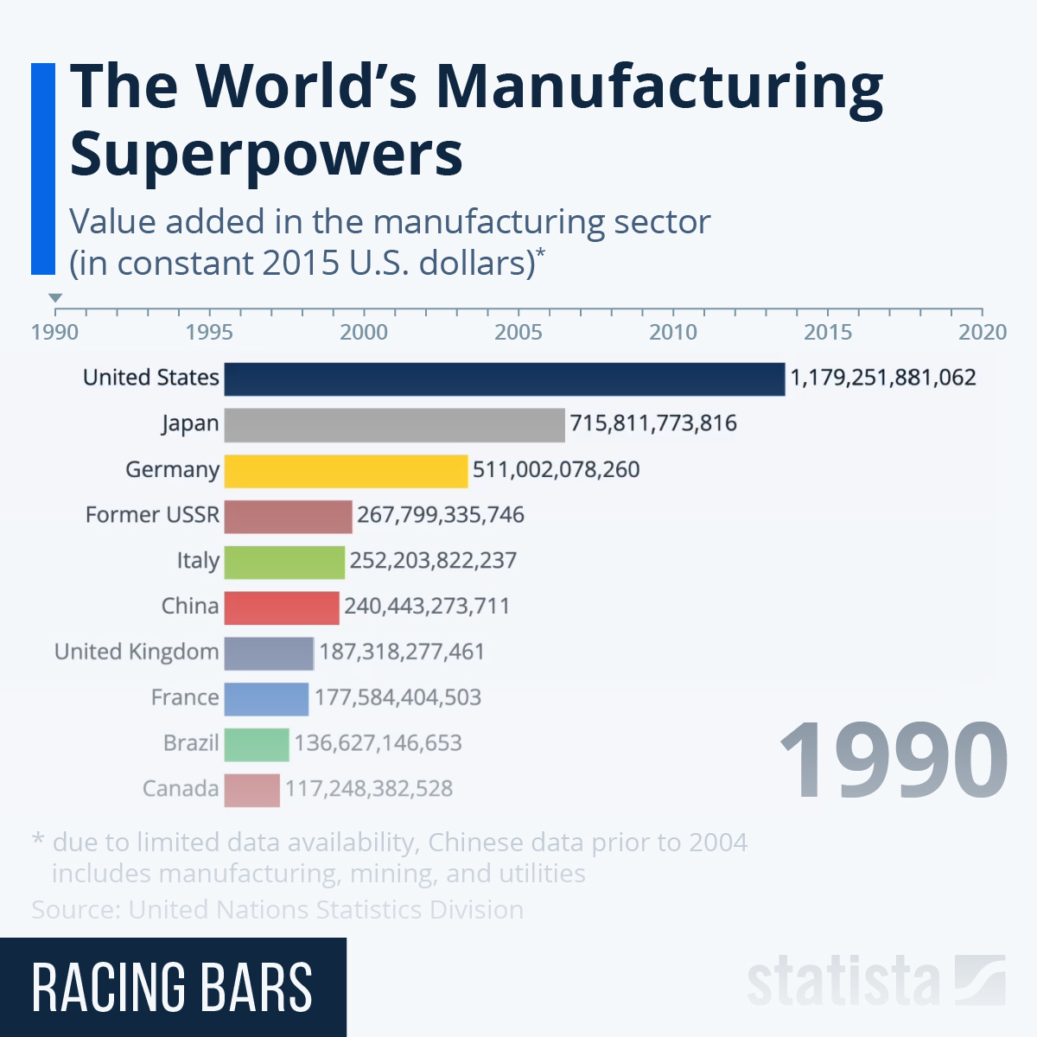
A global stocktaking on sustainable energy, to take place on 19 April 2024 under the auspices of the UN General Assembly, will be a major opportunity to accelerate action and strengthen multi-stakeholder partnerships, towards achieving clean and affordable energy for all -- Sustainable Development Goal 7 (SDG7) -- as well as the aims of the Paris Agreement on climate change.

Mandated by the General Assembly and scheduled as part of the Sustainability Week organized by the President of the General Assembly from 15 to 19 April, the overarching goals of the global stocktaking are to review the progress achieved at the conclusion of the UN Decade of Sustainable Energy for All (2014-2024) and to raise ambition while accelerating actions toward SDG7. This includes catalyzing innovative solutions, investments, and multi-stakeholder partnerships.

The global stocktaking builds upon the momentum generated by the high-level dialogue on energy in 2021, aiming to further advance progress on SDG7 within the 2030 Agenda and achieve a just and inclusive energy transition. One avenue for action will be expanding the over 200 Energy Compact voluntary commitments, totaling over $1.3 billion in investments and commitments through 2030, that have been made in connection with the high-level dialogue on energy and in its follow-up, supported by UN-Energy. Also among the key questions to be addressed is determining appropriate institutional arrangements beyond the UN Decade for continuing international cooperation on energy(UNIDO & the Sustainable Development Goals | UNIDO, n.d.).

Impact on Economic Growth and Societal Acceptance

- Economic Growth

One of the most significant challenges in deploying clean technologies such as wind turbines and solar energy systems in the distribution system is their inconsistent power generation due to their reliance on wind speed and sun radiation characteristics. Despite their unpredictable nature, in addition to the numerous environmental benefits, they provide more profit for the distribution corporation than traditional and unclean technologies.

Incorporating clean technologies into the distribution system alongside conventional distributed generation units i.e. a variety of technologies that generate electricity at or near where it will be used, results in a higher profit for the distribution company than relying solely on conventional units. Also, the optimal compromise between all technical, economic, and environmental aspects is achieved when both clean and conventional distributed generation units are present at the same time(Sadeghi & Kalantar, 2015).

1.1 Economic Growth in China

Cleantech and clean energy contributed a record 11.4 trillion yuan ($1.6 trillion) to China's economy in 2023, accounting for all investment growth and a bigger share of GDP than any other sector. According to the estimate, the primary emphasis of China's clean-energy investments in 2023 will be solar power, as well as manufacturing capacity for solar panels, EVs, and batteries(Myllyvirta, 2024). Industry data and analyst projections show a massive increase in investment in Chinese cleantech and energy in 2023:

- Clean-energy investment increased 40% year on year to 6.3 trillion yuan ($890 billion), accounting for all of the investment growth in the Chinese economy in 2023.
- China's $890 billion investment in clean-energy sectors is nearly equal to total global investments in fossil fuel supply in 2023 - and equivalent to the GDPs of Switzerland and Turkey.
- Clean-energy sectors provided 11.4 trillion yuan ($1.6 trillion) to the Chinese economy in 2023, increasing 30% from the previous year.
- As a result, clean-energy sectors were the primary driver of China's overall economic growth, accounting for 40% of GDP expansion in 2023.
- Without the development of clean-energy sectors, China's GDP would have missed the government's growth objective of "around 5%", rising by only 3.0%. instead of 5.2% (Fig.1).
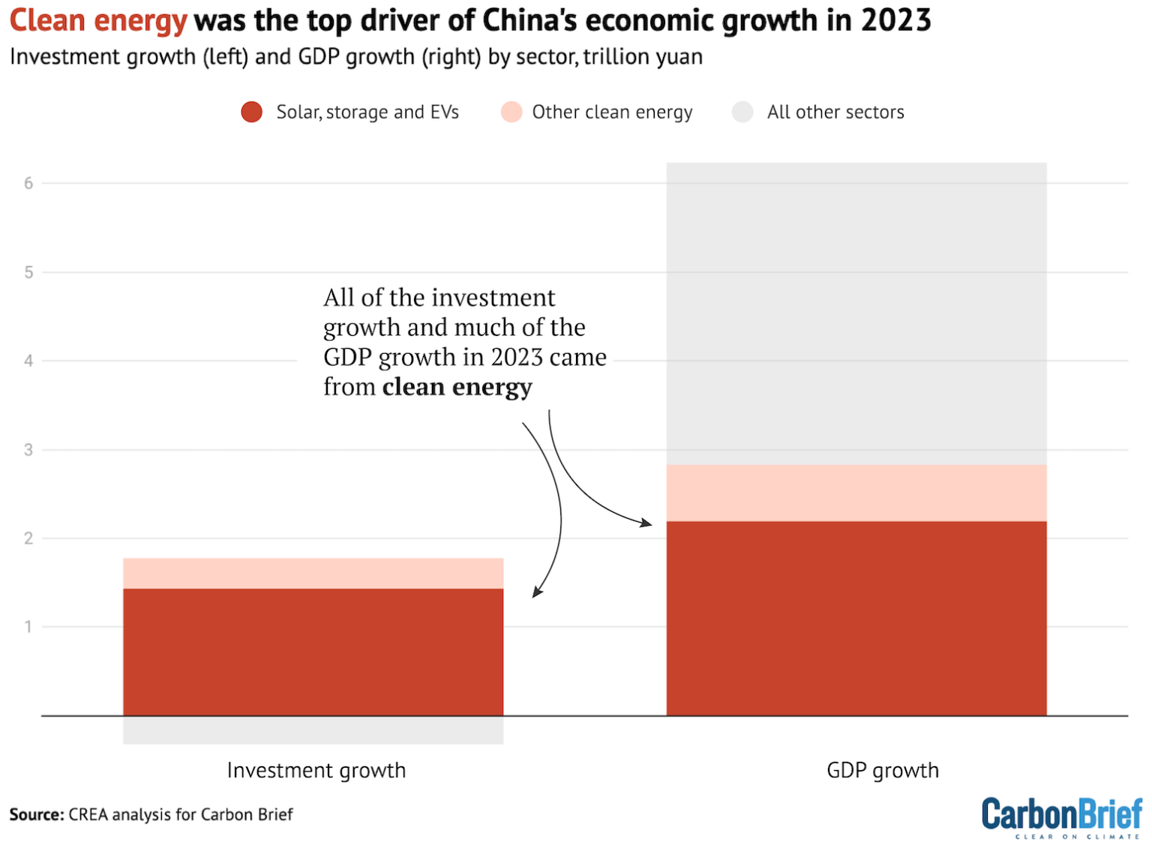
Fig. 1. China’s economic growth in 2023 regarding clean technology.

1.2 The “New Three”
The so-called "new three" of solar, storage, and EVs all have had significant economic growth. Investment in clean power generation and energy storage capacity reached 1.7 trillion yuan in 2023 (up 48% year on year), while investment in manufacturing capacity for solar, EVs, and batteries reached 2.5 trillion yuan (+60%). Investment in clean-energy infrastructure totaled 1.4 trillion yuan (+9%), including grids, EV charging sites, and trains, while investment in energy efficiency was 600 billion yuan (+15%).
Meanwhile, an estimate predicts that the value of goods and services produced in the clean-technology industries will reach 5.1 trillion yuan in 2023, a 26% increase over the previous year. This comprises the value of electricity generation, EV sales, and solar exports, as well as the transportation of passengers and products through rail(Myllyvirta, 2024).
1.2.1 Solar Power
Solar was the most important driver of growth in China's clean-technology economy in 2023. It saw growth worth a combined 1 trillion yuan in new investment, goods, and services, with its value rising from 1.5 trillion yuan in 2022 to 2.5 trillion yuan in 2023, a 63% increase year on year. While China has led solar panel manufacturing and installation for many years, the industry's rise in 2023 was unprecedented (Fig.2) (Myllyvirta, 2024).

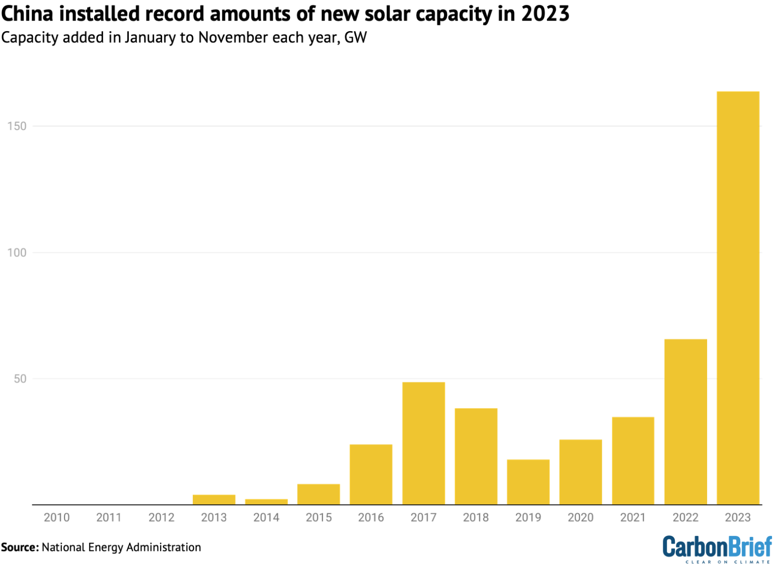
Fig. 2. Growth in China’s solar installations.

1.2.2 Wind Power
In the first 11 months of 2023, China saw a significant rise in wind power capacity installation, with 41GW added—a remarkable 84% increase compared to the previous year. China Galaxy Securities projects an additional 60GW of onshore wind capacity for the entire year of 2023, based on historical trends. Additionally, offshore wind capacity increased by 6GW over the same period.

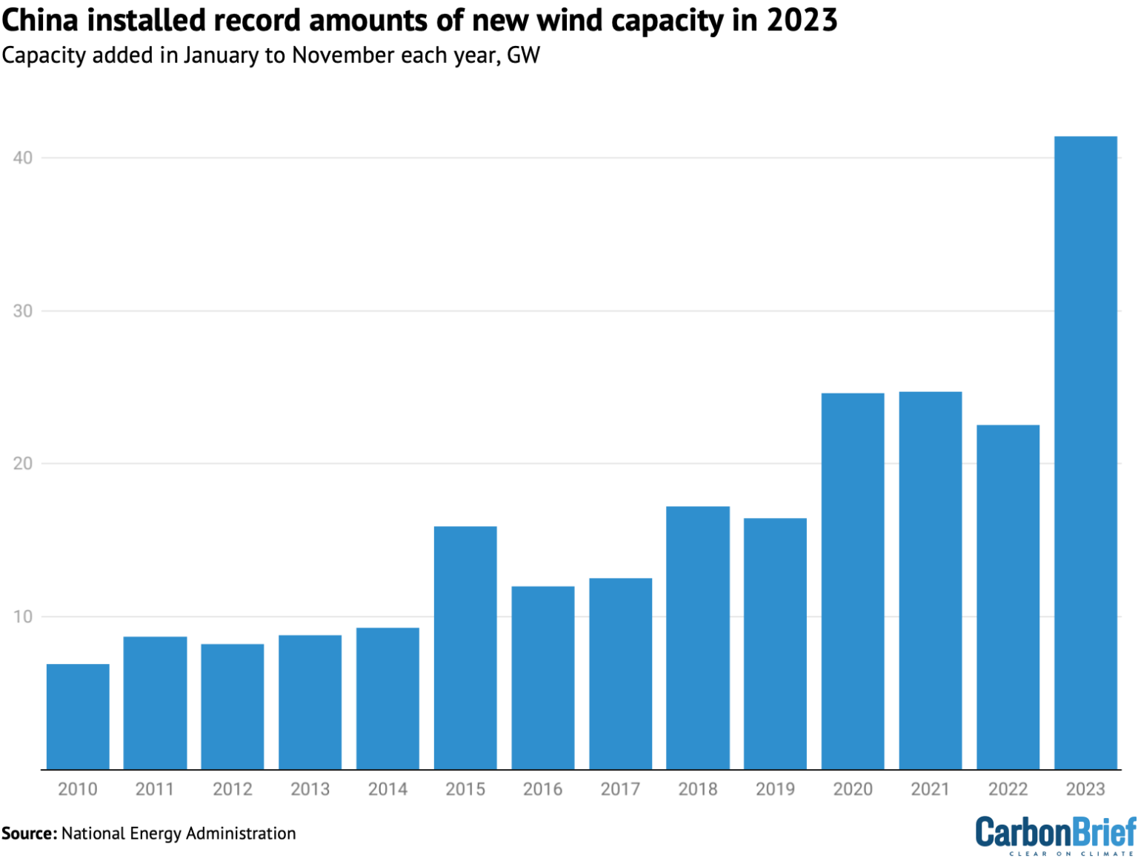
Fig. 3. Wind capacity added in the first 11 months of each year.
By the end of 2023, the first set of "clean-energy bases" was set to come online, enhancing onshore wind power capacity, especially in regions like Inner Mongolia and other northwest provinces. The following phases of clean-energy bases are expected to continue driving the growth of onshore wind installations. Despite technological developments that have reduced costs, rises in raw material prices have resulted in lower profit margins compared to the solar industry, resulting in a smaller overall investment in wind power than solar power(Myllyvirta, 2024).

1.2.3 Energy Storage and Hydrogen

China is quickly increasing its electrical storage capacity. This has the potential to drastically reduce China's reliance on coal and gas-fired power plants to satisfy peak electricity demand while also allowing for the inclusion of more variable wind and solar output into the system. The building of pumped hydro storage capacity has expanded considerably in the recent year, with capacity under construction reaching 167GW, up from 120GW the year before.

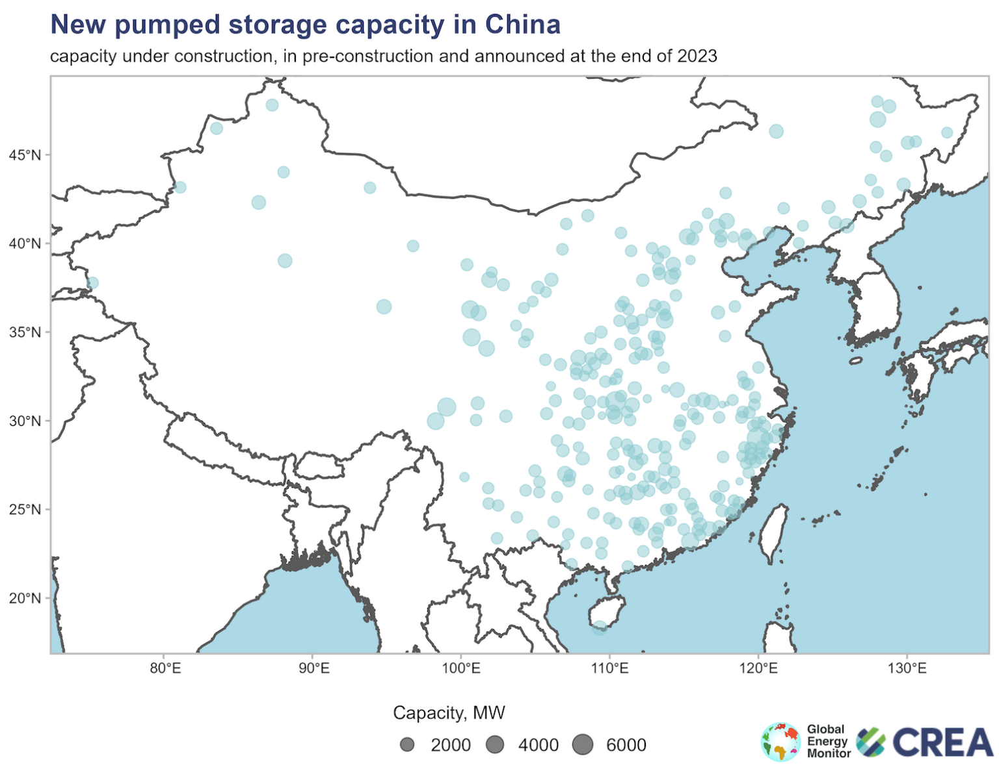
Fig. 4. Pumped hydro capacity under construction or in earlier stages of development at the end of 2023.
Investment in electrolysis equipment for "green" hydrogen production nearly doubled year on year in 2023, reaching around 90 billion yuan, according to SWS Research's first-half forecasts. Analyst reports and project compilations published in the news media place significantly higher numbers on China's investments in green hydrogen, but these typically include spending on power production, which is treated separately in this research.
Investment in "new energy storage technologies" (a category dominated by batteries) more than doubled in 2023, reaching 75 billion yuan. This estimate is based on newly added capacity in 2023 published by the China Energy Storage Alliance and average investment costs derived using National Energy Administration data(Myllyvirta, 2024).

- Societal Acceptance

A change in mindset is a complex task that cannot be accomplished in a short amount of time since it involves numerous dimensions, including political, technical, social, and economic issues, and necessitates sociopolitical activity at multiple levels of society. A study aimed to shed light on one sociopolitical aspect by investigating the social acceptance of the Clean Energy (CE) idea in Turkey—specifically, by assessing Istanbul citizens' knowledge of the notion.

2.1 Awareness and Acceptance

In 2009, a study was prepared and carried out to gain insight into the amount of knowledge and awareness of the CE idea among Istanbul inhabitants. The survey was intended to serve as a starting point for discussions about societal acceptance, specifically public acceptance, of the CE idea in Turkey.

The survey offered actual data on Istanbul citizens' knowledge of the CE idea and yielded several notable findings. The key finding of this study is that, in general, Istanbul residents understand the CE idea. As previously stated, 90% of participants believe that the CE concept is related to environmental friendliness, and half are aware of the ideal context for the concept, which includes not just environmental friendliness but also renewability (Fig.5).

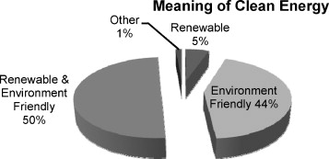

Fig. 5. Meaning of CE concept according to the participants.

Another study finding concerns the validation of preoccupations. According to the survey findings, the most common concern: "Awareness about clean energy concepts is expected to be higher with the education level" is partially justified.

Finally, while there may be differences amongst social sectors, Istanbul inhabitants largely embrace the CE concept and its implementation. However, in order to complete the context of this concept, they need to be provided with more information and the opportunity to use it in their daily lives (Erbil, 2011).

2.2 Understanding Social Acceptance

Social acceptance is an often used term in the practical policy literature, but clear definitions are rarely given. We intend to contribute to the clarity of understanding by distinguishing three dimensions of social acceptance, namely socio-political acceptance, community acceptance, and market acceptance (Wüstenhagen et al., 2007). All three, sometimes interdependent categories of social acceptance are studied in this special issue (Fig. 6).
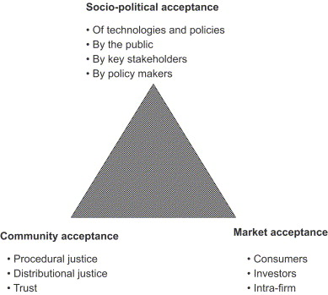

Fig. 6. The triangle of social acceptance of renewable energy innovation.

2.2.1. Socio-political acceptance

Socio-political acceptance refers to wide, all-encompassing societal acceptance. Both policies and technologies can be prone to societal acceptance (or rejection). Multiple indicators show that renewable energy technologies and policies are popular in many countries. This is demonstrated by surveys, in which huge majorities of people agree with the concept of public support for renewables, even in nations where the government does nothing to promote them. This positive overall picture of renewable energy is misleading policymakers into believing that social acceptance is not a problem.
However, as one moves from global to local, and from general support for technology and policies to effective positive investment and choice of location decisions, it is necessary to identify that a problem exists. In addition, while implementation rates are ultimately determined by the number of successful instances, the reality remains that there are significant differences in rates between countries that cannot be explained by differences in wind resources. Many of the challenges to successful project implementation can be attributed to a lack of social acceptance. At the broadest level of sociopolitical acceptance, this includes the acceptance of effective policies by major stakeholders and policymakers. These policies necessitate the establishment of frameworks that effectively support and enhance markets and community acceptance(Wüstenhagen et al., 2007).
2.2.2. Community acceptance
The second factor of social acceptance of renewable energy innovation, namely community acceptance, has been recognized by researchers from an early stage. Community acceptance is the specific acceptability of siting decisions and renewable energy projects by local stakeholders, especially residents and municipalities. This is where the debate over NIMBYism takes place, with some arguing that the difference between general acceptance and then resistance to specific projects can be explained by the fact that people support renewable energy as long as it is not in their own backyard, while others argue that this is an oversimplification of people's true motivations(Wüstenhagen et al., 2007).
Others have discovered evidence for the exact opposite effect, specifically that opposition decreases rather than increases with the degree of direct impact of a certain wind power project. One distinguishing element of community acceptance is that it has a time dimension. As Wolsink (2007) demonstrates in this issue, the typical pattern of local acceptance before, during, and after a project follows a U-curve, transitioning from high acceptance to (relatively) low acceptance during the siting phase (which is usually still positive on average) and then returning to a higher level of acceptance once the project is operational.

Benefits and Challenges

Mostly all around, humanity has some problems regarding the devastating effects on the environment and also the ecosystem. Humanity has faced extreme weather, floods, high temperatures, haze, air pollution, water pollution, and many other issues regarding the environment. However, through the implementation of clean technology and environmentally friendly advancement, humanity will have the ability to hold back on these issues that have damaged the environment.
The primary purpose of clean technology is to protect biodiversity and mitigate the negative effects on human beings. Clean technology offers significant advantages not only for biodiversity itself but also for a healthier and greener lifestyle. As of now or even in the future human beings would like to stay alive and breathing on this earth without having any ecosystem problems. These clean technologies, systems, and applications will help to guarantee the planet remains stable for the continued survival of all organisms.

As we are moving towards a globalization world, clean technology fields are becoming more trending nowadays. Many researchers from all over the world are doing study and research on this topic. Clean technology has a more positive impact not only on the environment but towards the human lifestyle. The advantage of having this clean technology is it will never be harmful to the environment and also it reduces the effects of global warming due to CO2 emissions.

Considering all these benefits, there are also challenges to clean technology. Green innovation adoption (GIA) faces significant challenges in achieving sustainable development (SD) in manufacturing organizations due to various decision-making factors. However, there are no specific criteria for categorizing green technology adoption globally. There are still many concerns regarding adopting green and novel technologies, e.g. financial barriers, environmental policies, market demand, knowledge, and awareness (Nazir, 2021).

Adopting green innovation is one of the challenges. GIA requires innovative organizational strategies to switch their classical and traditional means of production to novel and sustainable operations. Nevertheless, transformation into sustainable operations remains difficult for organizations because multiple uncertainties and complexities are involved in the transformation procedure. The reluctance of individuals and companies to turn to high-value and costly technologies such as installation and maintenance is the result of non-existent policies.

Green performance expectancy (GPE) Performance expectancy is an important variable of the GIA model that affects behavioral intentions. "It is the degree to which the individual believes that using the system will help him achieve gains in job performance". Many scholars have modeled the critical elements of technology adoption for better decision-making and verified the rationality of its attributes, which are further developed in the GIA model (Shahzad et al., 2022).

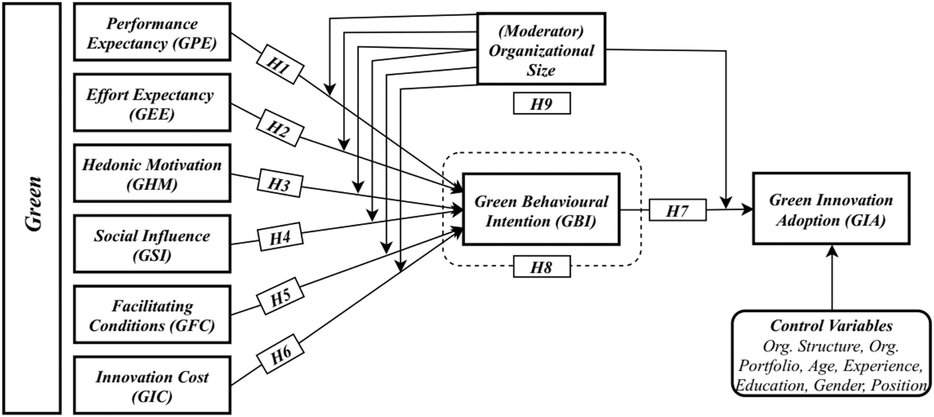

Fig.1. The research framework of the GIA.

Relevant UN Treaties and Campaigns

The Montreal Protocol (1987)
The primary goal of the Montreal Protocol is not clean technology, but it has led to the development and adoption of cleaner alternatives in industries such as refrigeration and air conditioning. The main purpose of the protocol is to gradually reduce the use of substances that damage the ozone layer and to protect this layer surrounding the world. The Montreal Protocol, to which 196 countries are parties, is considered the most successful multilateral agreement on the environment. The Montreal Protocol, for the first time in history, envisaged the restriction of human-derived substances that deplete the ozone layer on the basis of a multilateral agreement, in the light of scientific results that were not yet certain at that time. This model applied to the ozone layer has set a kind of precedent for the climate change regime. In this context, the Montreal Protocol constituted a turning point in the creation of the UN Framework Convention on Climate Change (UNFCCC). In other words, the Montreal Protocol is a milestone that paves the way for clean technology (Republic of Türkiye Ministry of Foreign Affairs, n.d.).

United Nations Framework Convention on Climate Change (UNFCCC)

In response to the effects of global warming on the climate caused by human-induced activities put forward by the Intergovernmental Panel on Climate Change (IPCC), which was jointly established by the UN Environment Program (UNEP) and the World Meteorological Organization (WMO) in 1988, in Rio de Janeiro in 1992. The UNFCCC, which was opened for signature at the United Nations (UN) Environment and Development Conference held in 2015, is the first and most important step taken internationally. UNFCCC; It encourages party countries to reduce greenhouse gas emissions (indirectly work on clean technology), cooperate on research and technology, and protect greenhouse gas sinks (e.g. forests, oceans, lakes). The Convention is based on the principle of "common but differentiated responsibilities and relative capabilities" to reduce greenhouse gas emissions, taking into account the development priorities and special conditions of the countries (Republic of Türkiye Ministry of Foreign Affairs, n.d.-b). The Kyoto Protocol, signed in 1997 within the scope of this agreement, contains more concrete goals.

The Kyoto Protocol (1997)

The Kyoto Protocol was one of the first international agreements aimed at reducing greenhouse gas emissions, but it was largely abolished by the Paris Agreement. Three flexible mechanisms have emerged in this protocol. These flexible mechanisms include Emissions Trading (ETS), the Clean Development Mechanism (CDM), and Common Implementation (JI). These are mechanisms defined under the Kyoto Protocol that aim to reduce the overall costs of meeting emissions targets (United Nations, n.d.).

The Paris Agreement (2015)

The Paris Agreement is a continuation of the Kyoto Protocol. Both treaties were concluded under the United Nations Framework Convention on Climate Change with the objective of stabilizing greenhouse gas concentrations in the atmosphere and preventing dangerous human interference with the climate system. The Kyoto Protocol required only developed countries to reduce emissions, while the Paris Agreement recognized that climate change is a shared problem and called on all countries to set emissions targets. The Kyoto Protocol did not compel developing countries, including major carbon emitters China and India, to take action. The United States signed the agreement in 1998 but never ratified it and later withdrew its signature. The Paris Agreement, which now has 194 Parties, requires all countries to reduce their emissions. Governments set targets, known as nationally determined contributions, with the goals of preventing the global average temperature from rising more than 2°C above pre-industrial levels and pursuing efforts to keep temperature rise below 1.5°C (United Nations, n.d. ). Clean technology plays a key role in achieving these objectives by reducing greenhouse gas emissions across various sectors such as energy, transportation, and industry.

Sustainable Development Goals

The United Nations approved the Sustainable Development Goals (SDGs), also known as the Global Goals, in 2015 as a global call to action to eliminate poverty, protect the environment, develop clean technology, and ensure that all people live and thrive in peace by 2030. There are 17 of these goals and they are all interconnected. It is recognized that actions in one area have an impact on outcomes in other areas and that development must strike a balance between social, economic, and environmental sustainability (Sustainable Development Goals, n.d.). Detailed information about the Sustainable Development Goals is available in the fourth title of this study guide.

Global Cleantech Innovation Programme

GCIP was launched in 2011 at COP17 in South Africa to address the global climate change challenge. GCIP’s primary objective is to identify and support innovative clean technology solutions in developing countries through business acceleration and investment facilitation services designed specifically for clean technology companies operating in developing countries. GCIP is a program led by the United Nations Industrial Development Organization (UNIDO) in partnership with the Global Environment Facility (GEF) and the Green Climate Fund (GCF). GCIP promotes clean technology innovation and entrepreneurship in emerging and developing countries to address climate challenges and promote sustainable development. GCIP provides comprehensive support to micro, small, and medium enterprises, which form the backbone of emerging and developing economies, helping them bring solutions to market. GCIP directly supports clean technology innovators through business acceleration training, mentorship, networking, and financing facilitation. GCIP also helps partner countries strengthen their national innovation and entrepreneurship ecosystems. GCIP builds the capacity of national institutions, contributes to the development of inclusive national policy frameworks, and creates partnerships among public, private, and academic sector stakeholders (Global Cleantech Innovation Programme, n.d.).

Previous Attempts to Solve the Issue

Incentive Policies

Supporting companies and manufacturers with funding policies on the use of clean technology; For instance, the Chinese government has already integrated GI in the Constitution 2018, laying the groundwork to promote a green technology bank for supporting clean technology adoption. Further, GI (green innovation) enabled organizations to manufacture eco-friendly products by minimizing resource utilization and wastage to accomplish SD (sustainable development).

Legislation

Enacting environment protection laws and laws for companies and manufacturers to use clean technology. Being the seventh most susceptible nation to climate change, Pakistan should seek sustainable and green technological solutions; it is regarded as one of the least innovative countries with a poor ranking in Asia as well as in the world (Global Innovation Index, 2018). Due to poor air quality, the famous industrial city Lahore used to be declared the most polluted in the world recently. To overcome these environmental problems and consider SD, the current leadership of Pakistan implemented stringent environmental laws to protect the environmental deterioration and tried to facilitate the organizations to lessen their dependence on fossil fuels and exploit renewable energy resources

Possible Solutions

Carbon Dioxide Utilization

Chemical usage of Carbon Dioxide refers to methods that convert Carbon Dioxide into other high-value compounds under certain conditions of temperature, pressure, and catalyst. Carbon Dioxide chemical use can directly realize the conversion and utilization of Carbon Dioxide and cause a direct reduction in emission impact. This type of technology has the potential to replace fossil fuels such as oil, which are widely used today. In order to realize this potential, various techniques such as thermochemical catalysis can be developed in the next five years. This corresponds to two general meetings because Member States of UNIDO meet every two years at the General Conference. The last general conference of UNIDO was held in December 2023 (Pacific Northwest National Laboratory, n.d.).

Environmentally Friendly and Agricultural Food Production Systems

Optimizing the use of agricultural fertilizers and water can significantly reduce greenhouse gas emissions in crop production systems. To increase nitrogen use efficiency, new types of compound Nitrogen fertilizers should be developed, including slow and controlled-release Nitrogen fertilizers, as well as Nitrogen fertilizers containing urease and nitrification inhibitors. The use of advanced agricultural methods, fertilization, and irrigation practices, as well as high-tech electronic agricultural technologies in the form of multi-sensor aerial drones, to enable farmers to more efficiently and responsibly manage crop production, land, fertilizer application, and water management can reduce emissions (Aysündü, 2024) .

Green Buildings

Green building can be defined as the practice of designing buildings and utilizing environmentally sustainable and efficient resource techniques over the lifecycle of a construct. This includes from setting to layout, constructing, managing, servicing, restoration, and everything from the selection of building supplies to the location of the building (Tahir et al., 2015). The main focus of green building is to guarantee that designs for green construction minimize the total impact on human health and the environment.

Recycle and Reduce Regulations

Recycling, reducing, and reusing regulations implemented by governments all greatly help enterprises reduce carbon emissions by reducing fossil energy use throughout the entire supply chain. The fewer new products are developed from raw minerals and fossil fuels, the less interest there is in extracting raw materials and mining. Recycled paper, cardboard, and reusable bags can all help reduce environmental impact (European Commission, n.d.).

Questions to be Answered

- How can countries incentivize the adoption of clean technology within their industrial sectors while ensuring economic competitiveness?
- What role can international cooperation and partnerships play in promoting the global adoption of clean technology?
- How can clean technology adoption be integrated into national development strategies to foster sustainable economic growth?
- What measures can be taken to overcome barriers to the widespread implementation of clean technology, particularly in developing countries?
- How can clean technology initiatives be designed to address both environmental sustainability and socio-economic development goals?
- What strategies can be employed to promote public awareness and societal acceptance of clean technology solutions?

Bibliography

All About the NDCs | United Nations. (n.d.). United Nations. https://www.un.org/en/climatechange/all-about-ndcs

Aysündü, İ. (2024). Agriculture and Food System. European Environment Agency’s home page. https://www.eea.europa.eu/en/topics/in-depth/agriculture-and-food

Dincbas, T., Ergeneli, A., & Yiǧitbaşıoǧlu, H. (2021). Clean technology adoption in the context of climate change: Application in the mineral products industry. Technology in Society. https://doi.org/10.1016/j.techsoc.2020.101478

Erbil, A. T. (2011). Social acceptance of the clean energy concept: Exploring the clean energy understanding of Istanbul residents. Renewable and Sustainable Energy Reviews, 15(9), 4498–4506. https://doi.org/10.1016/j.rser.2011.07.101

European Commission. (n.d.). Waste and recycling. Environment. https://environment.ec.europa.eu/topics/waste-and-recycling_en

GA Resolution. (2015). General Assembly 2015 Resolution. https://undocs.org/Home/Mobile?FinalSymbol=A%2FRES%2F70%2F1&Language=E&DeviceType=Desktop&LangRequested=False

Global Cleantech Innovation Programme. (n.d.). United Nations Global Cleantech Innovation Programme. GCIP. https://gcip.tech/

Myllyvirta, L. (2024). Analysis: Clean energy was top driver of China’s economic growth in 2023. Carbon Brief. https://www.carbonbrief.org/analysis-clean-energy-was-top-driver-of-chinas-economic-growth-in-2023/

Nazir, N. (2021). Development of green technology from the past to the future development: a systematic literature review paper. Systematic Literature Review and Meta-Analysis Journal, 2(1), 25–37. https://doi.org/10.54480/slrm.v2i1.13

Pacific Northwest National Laboratory. (n.d.). Carbon Utilization. PNNL. https://www.pnnl.gov/carbon-utilization

Republic of Türkiye Ministry of Foreign Affairs. (2022). United Nations Industrial Development Organisation (UNIDO) / T.C. Ministry of Foreign Affairs. https://www.mfa.gov.tr/birlesmis-milletler-sinai-kalkinma-teskilati-unido.tr.mfa

Republic of Türkiye Ministry of Foreign Affairs. (n.d.). Montreal Protocol / Republic of Türkiye Ministry of Foreign Affairs. https://www.mfa.gov.tr/viyana-sozlesmesi-ve-montreal-protokolu.tr.mfa

Republic of Türkiye Ministry of Foreign Affairs. (n.d.). United Nations Framework Convention on Climate Change / Republic of Türkiye Ministry of Foreign Affairs. https://www.mfa.gov.tr/bm-iklim-degisikligi-cerceve-sozlesmesi.tr.mfa

Sadeghi, M., & Kalantar, M. (2015). The analysis of the effects of clean technologies from economic point of view. Journal of Cleaner Production, 102, 394–407. https://doi.org/10.1016/j.jclepro.2015.04.042

Shahzad, M., Qu, Y., Rehman, S. U., & Zafar, A. U. (2022). Adoption of green innovation technology to accelerate sustainable development among manufacturing industry. Journal of Innovation & Knowledge, 7(4), 100231. https://doi.org/10.1016/j.jik.2022.100231

Sustainable Development Goals. (n.d.). UNDP. https://www.undp.org/sustainable-development-goals

UNIDO & MDG. (2010). In https://www.unido.org/sites/default/files/2010-04/mdgbrochure2_0.pdf.

UNIDO & the Sustainable Development Goals | UNIDO. (n.d.). United Nations Industrial Development Organization. https://www.unido.org/unido-sdgs

United Nations Industrıal Development Organisation. (2023). Partnerships | UNIDO. UNIDO | United Nations Industrial Development Organization. https://www.unido.org/about-us/partnerships

United Nations. (n.d.). Marking the Kyoto Protocol’s 25th anniversary. United Nations | Climate Action. https://www.un.org/en/climatechange/marking-kyoto-protocol’s-25th-anniversary

Wolsink, M. (2007). Planning of renewables schemes: Deliberative and fair decision-making on landscape issues instead of reproachful accusations of non-cooperation. Energy Policy, 35(5), 2692–2704. https://doi.org/10.1016/j.enpol.2006.12.002

Wüstenhagen, R., Wolsink, M., & Bürer, M. J. (2007). Social acceptance of renewable energy innovation: An introduction to the concept. Energy Policy, 35(5), 2683–2691. https://doi.org/10.1016/j.enpol.2006.12.001

