TABLE OF CONTENT
- Letter from the Secretary General
- Letter from the President Chair
- Introduction to the Committee
- Introduction to the Agenda Item
  - Concept of Nuclear Safety
  - Importance of Nuclear Safety
  - Definition of Nuclear Disasters
- Theoretical Framework
  - Overview of the IAEA
  - Safeguards of the IAEA
- Historical Background
  - Kyshtym Disaster (September 29, 1957)
  - Three Mile Island Accident (March 28, 1979)
  - Chernobyl Disaster (April 26, 1986)
  - Fukushima Daiici Accident (March 11, 2011)
- Relevant Information Regarding the Topic
  - Past Resolution Attempts
  - The Treaty on the Non-Proliferation of Nuclear Weapons (NPT)
  - The Convention on the Nuclear Safety (CNS)
  - Safety standards established by the IAEA
- Bibliography

- Letter from the Secretary General

Most distinguished participants and dearest guests,

I am delighted to welcome you to the HASMUN’24 Conference of Kadir
Has University as the Secretary-General. Your participation and unique
perspectives will contribute to the success of this event.
With 8 diverse committees, each crafted to address the urgent need
forsolutions across a broad spectrum of specializations, we're set for
impactful discussions and innovative ideas. With our special 15th year of
Kadir Has University Model United Nations Club celebration, our
committees are:

• United Nations Office of Counter-Terrorism (UNOCT)
• International Atomic Energy Agency (IAEA)
• United Nations Population Fund (UNFPA)
• United Nations Industrial Development Organization (UNIDO)
• United Nations Office for Outer Space Affairs (UNOOSA)
• World Food Programme (WFP)
• International Monetary Fund (IMF)
• Historical Crisis Committee (HCC)

We, as the HASMUN'24 team, have made marvelous efforts to serve you,
participants, one of the greatest Model United Nations Conferences.
I want to conclude my words by thanking everyone involved in the
Academicand Organization teams for their greatest work. Delegates, I look
forward to your valuable contributions and meeting you in person.
#welcomehome
Best regards,
Aylin Rassad
Secretary-General HASMUN'24
- Letter from the President Chair

Esteemed delegates,

It is my pleasure to welcome you all to HASMUN’24 and the IAEA committee. I am İlayda Büyükulcay, a sophomore student at İstanbul University Department of Political Science and International Relations and I will be serving as the President Chair of our committee. As the President Chair of this committee, I am honored to take on the responsibility of guiding you through this vitally important session, which will focus on "Precautions that can be taken to prevent a nuclear disaster from occurring again".

Our history is full of unforgettable events that underscore the potentially destructive power of nuclear energy. Disasters such as Chernobyl and Fukushima are a painful reminder that neglect of nuclear safety can have long-term, devastating effects, not only in the immediate affected regions, but across the globe. These events underscore the importance of international cooperation and vigilance in the management and oversight of nuclear technology.

Preventing another nuclear disaster is a global issue that directly affects the well-being of all humanity, not just a few countries. It has the potential for a crisis with serious consequences for societies, civilizations, and all of humanity. Nuclear safety is not only an environmental issue, but also critical to the maintenance of global peace and security.

Therefore, as the IAEA Committee, it must be our priority to identify and implement measures that can be taken to prevent another nuclear catastrophe. The decisions to achieve this goal will be in the hands of you, the delegates.

I would like to emphasize that this issue is of the utmost importance for our survival and that of future generations. The situation that we are trying to prevent today, we have experienced many bad consequences in history. For this reason, the disasters that have happened are a great example for us and will help us learn lessons for the future.

Lastly, I would like to thank my Deputy Chair Zeynep Çevik and my Academic Assistant Yusuf Kayra Öz for their contributions during the preparation of this committee. We have gathered a lot of necessary information for you in the study guide. Therefore, reading the guide thoroughly and doing further research will be a great help for you in the committee. Also, in order to better understand the committee and your country and to participate, it is required for everyone to write a position paper. Please send it to ilaydabuyukulcay@ogr.iu.edu.tr by 23.00 on April 11th. Please do not hesitate to approach us with any questions or concerns during the 2-day conference. Wishing you a pleasant academic and diplomatic experience.

Best regards,

İlayda Büyükulcay
President Chair of the IAEA Committee

- Introduction to the Committee

Welcome to the International Atomic Energy Agency (IAEA) committee where we will focus on nuclear weapons. The purpose of our committee of the International Atomic Energy Agency (IAEA) is to prevent the proliferation of nuclear weapons, which is one of the greatest threats facing the world, and to prevent a nuclear explosion from occurring again. The existence of nuclear weapons poses a serious threat to international peace and security, not only because of the destructive power they possess, but also because they carry the risk of being used for reasons such as accidents, miscalculations, and terrorism.

The work of this committee will determine policies in the field of nuclear disarmament and nuclear security and will ensure that all member states act together in this direction. Our priorities include strengthening the nuclear non-proliferation regime, increasing international cooperation to prevent nuclear accidents, and taking effective measures to counter nuclear terrorism.

We invite you to discuss and shape the policies and strategies necessary to overcome the threats posed by nuclear weapons and to promote the peaceful use of nuclear technology. Together, we can take concrete steps towards a safer world and prevent nuclear weapons from being used for evil purposes.

In addition, we may encounter events and problems that we cannot predict during our diplomatic solutions, and we may face crises. For this reason, your crisis-solving skills will undoubtedly have an important place in this committee. However, you should keep in mind that another catastrophe could also unleash a larger global crisis.

The fact that nuclear weaponization continues day by day and increases threats reveals the inadequacy of existing measures. For this reason, at the end of this committee, you will create a new treaty and try to take an effective measure to prevent future threats.

Do not forget that the biggest situation of these nuclear explosions is that they endanger our health. As the existing technology changes and develops, this danger will reach greater dimensions. For this reason, the future of the world will be in your hands.

- Introduction to the Agenda Item
  - Concept of Nuclear Safety

Nuclear energy is the energy ingenerated from atomic fission and fusion that is basically atoms splitting and exuding a high amount of energy which then forms its own source. Nuclear power plants are those that generate electricity using radioactive elements. Nuclear reactors, the building units of nuclear power plants, use heat from the fission process to turn water into steam, which powers turbines. Overall, nuclear energy produces profitable results and is an energy source that is renewable and sustainable. In terms of usability, nuclear energy is environmentally friendly and a preferable option which may also have its disadvantageous impacts.

According to the World Nuclear Association, the usage of nuclear power was first developed in the 1940s, and during the Second World War research initially focused on producing bombs. In the 1950s attention turned to the peaceful use of nuclear fission, controlling it for power generation. When the commercial nuclear industry began in the 1960s, there were clear boundaries between the industries of the East and West. Today, the nuclear industry is characterized by international commerce. A reactor under construction in Asia today may have components supplied from South Korea, Canada, Japan, France, Germany, Russia, and other countries.

The uses of nuclear technology extend well beyond the provision of low-carbon energy. It helps control the spread of disease, assists doctors in their diagnosis and treatment of patients, and powers our most ambitious missions to explore space. These varied uses position nuclear technologies at the heart of the world's efforts to achieve sustainable development.

  - Importance of Nuclear Safety

As the utilization of nuclear energy involves a significant quantity of radioactive materials, nuclear safety is very crucial and something that all nations must take responsibility for. It goes without saying that the International Atomic Energy Agency was established in order to guarantee a safe framework for any action involving the use of nuclear energy. This framework demonstrates the need and the effort to provide a methodical application of safety measures.

Nuclear waste is typically one of the main issues for which these measures are taken. They are mostly brought on by the multifaceted overlook that disposal strategies are subjected to. The proper disposal of radioactive , mainly enriched uranium since it is the most common element that is used in such cases, must adhere to established rules. Deviation from these guidelines may result in irreversible consequences due to inevitable risks. Yet as mentioned earlier, the International Atomic Energy Agency is working on safety precautions. If they are implemented properly, significant risks can be avoided, and a significant step toward permanently switching to an environmentally friendly energy source like nuclear power can be made.

All activities involving the use of radioactive material require careful attention to safety and security. Safety is aimed at preventing accidents; security is aimed at preventing intentional acts that might harm the facility or result in the theft of nuclear materials.
Although these activities have a different focus, they overlap each other. Actions that are taken to further one activity can have implications for the others. Concerns about a radioactive release have long provided the justification for an emphasis on safety. In the aftermath of the 9/11 terror attacks and subsequent terrorist activities around the globe, operators, regulators and international organizations have all given increased attention to ensuring adequate security at facilities using radioactive material.

  - Definition of Nuclear Disasters

Nuclear disasters are some sequences of events where a huge amount of radioactive materials are released to the environment or the core of reactors melt. They are often defined as “events occurring in a nuclear power plant or anywhere that radioactive materials are used, stored, or transported and involving the release of potentially dangerous levels of radioactive materials into the environment.”.
The consequences of natural disasters are often lethal and usually irreversible. Some technical measures to reduce the risk of accidents or to minimize the amount of radioactivity released to the environment have been adopted. Despite the use of such measures, there have been many accidents with varying impacts as well as near misses and incidents.

At high doses, ionizing radiation can cause immediate damage to a person’s body, including, at very high doses, radiation sicknessand death. At lower doses, ionizing radiation can cause health effects such as cardiovascular disease and cataracts, as well as cancer. It causes cancer primarily because it damages DNA, which can lead to cancer-causing gene mutations.
Children and adolescents can be more sensitive to the cancer-causing effects of ionizing radiation than adults because their bodies are still growing and developing. Also, children and adolescents usually have more years of life following radiation exposure during which cancer may develop.
For example, following the Chernobyl disaster, the UN Chernobyl Forum described the effects of the accident on plants and animals. The Forum noted increased mortality of coniferous plants, soil invertebrates and mammals in the exclusion zone, as well as reproductive failure in plants and animals. It notes that genetic abnormalities attributable to radiation have been reported in plants and animals both inside and outside the exclusion zone, particularly in the years following the accident.
In other words, the impact of nuclear disasters is not only limited to the deaths of the people in the region at the time, but the radiation emitted continues to remain in people's genes, and with the transmission of this, it can bring many major diseases to their children. At the same time, the radiation emitted into the larger environment can cause many mutations in plants and change the natural environment.

- Theoretical Framework
  - Overview of the IAEA

The International Atomic Energy Agency promotes the safe, secure, and peaceful applications of nuclear science and technology, supporting global peace and security as well as the Sustainable Development Goals of the United Nations. It is the primary global intergovernmental forum for scientific and technical cooperation in the nuclear field.

The IAEA is also a key player in the effort to prevent nuclear terrorism. It provides a variety of advisory and support services to help states strengthen nuclear security, including by enhancing the security of vulnerable nuclear and radiological materials, reducing the risk that such material could be acquired by terrorists. Moreover, the IAEA enhances national, regional, and international capacities to respond to nuclear and radiological incidents, which is essential to minimizing their impact. In the event of an incident, the IAEA plays a lead role in providing timely and authoritative information to the international community.

  - Safeguards of the IAEA

IAEA safeguards are a set of technical measures that allow the IAEA to independently verify a State’s legal commitment not to divert nuclear material from peaceful nuclear activities to nuclear weapons or other nuclear explosive devices. Pursuant to the IAEA’s Statute, which authorizes the IAEA to establish and administer safeguards, States accept the application of such measures through the conclusion of safeguards agreements with the IAEA. IAEA safeguards are embedded in legally binding agreements, providing the basis for the IAEA to implement effective verification.

The vast majority of safeguards agreements are those that have been concluded by the IAEA with non-nuclear-weapon States (NNWSs) party to the Treaty on the Non-Proliferation of Nuclear Weapons (NPT). Under the NPT, these States have committed not to produce or otherwise acquire nuclear weapons and to place all of their nuclear material and activities under IAEA safeguards and to allow the IAEA to verify their commitments.

Similar to the NPT, the Treaty for the Prohibition of Nuclear Weapons in Latin America and the Caribbean (Treaty of Tlatelolco, 1967) requires its parties to conclude a comprehensive safeguards agreement (CSA) with the IAEA – as do the other regional nuclear- weapon-free zone treaties, including the South Pacific Nuclear Free Zone Treaty (Treaty of Rarotonga, 1985), the Southeast Asia Nuclear-Weapon-Free Zone Treaty (Treaty of Bangkok, 1995), the African Nuclear-Weapon-Free Zone Treaty (Treaty of Pelindaba, 1996) and the Central Asian Nuclear-Weapon-Free Zone Treaty (Treaty of Semipalatinsk, 2006).

- Historical Background
  - Kyshtym Disaster (September 29, 1957)
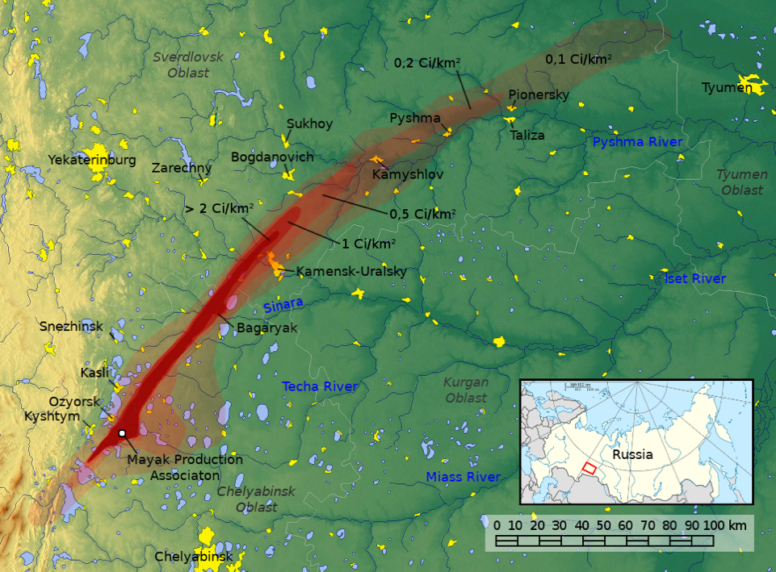
On September 29th, there was a failure in the cooling system of a waste storage tank, which caused the temperature inside the tank to rise and the cooling liquid to evaporate. As a result, the 70 to 80 tonnes of radioactive waste present experienced a significant increase in temperature, leading to a chemical explosion known as the Kyshtym accident, which occurred at approximately 4:20 pm that afternoon. The incident caused considerable harm to the container and dispersed radioactive substances into the surrounding environment. The resulting aerosol plume rose to an altitude of around 1000 meters and spread the ejected material over a wide area. Approximately 90% of the 740 PBq of mixed fission products were deposited as particulate material within a 5 km radius of the tank. The remaining 74 PBq of radioactive material was deposited as dry fallout over an area approximately 30-50 km wide and 300 km long, extending north-northeast of the Mayak facility.

In 1992 a case referent study of L-B residents, matched by sex, age and socio-occupational status with less radiation exposed residents of Oktyabrsky-Borough residents (O-B) was undertaken. Children living in LB with parents or grandparents who had been exposed here to maximum radiation in 1957-1962 as well as children living in rural villages outside radioactivity contaminated areas where their parents had been resettled in 1957-1959 from those most densely contaminated with radioactivity also showed poorer health status on the tests used, including laboratory, clinical and health history criteria. Children with several exposed parents or grandparents showed greater effects than those with lesser numbers of such forebears.

  - Three Mile Island Accident (March 28, 1979)
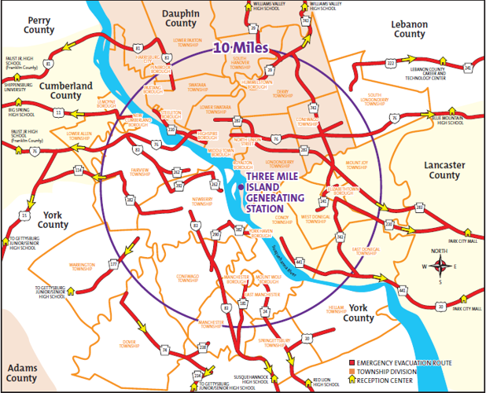
On March 28, 1979, TMI 2 near Harrisburg, Pa., was operating at about 100 percent power when it automatically shut down after a pump that provided cooling water stopped operating. Pressure and temperature increased in the reactor, causing a pressure relief valve to open. The valve opened as designed, and water and steam began flowing out of the reactor to a tank in the basement of the reactor building.As pressure returned to normal, the valve should have closed. But, unknown to the operators, the valve stuck open. It remained open for more than two hours, allowing water that covered and cooled the fuel core to escape from the reactor system. This caused the fuel to begin to overheat.However, instrumentation in the TMI control room indicated to the operators that the relief valve was closed and that too much water was being injected into the reactor vessel. Consequently, operators did not replace the water that was lost as a result of the open relief valve.As pressure continued to drop, more and more coolant turned to steam, causing excessive vibration in the main coolant pumps. The vibration prompted operators, who did not realize the reactor was experiencing a loss of coolant, to shut down the pumps.The loss of pressure and water caused a large steam bubble to form in the top of the reactor vessel, further preventing the flow of cooling water through the core. Without coolant, core temperatures rose above the melting point of the fuel cladding and the uranium fuel.About half of the fuel melted before coolant flow was restored. The colder cooling water also shattered some of the hot fuel rods. All of the fuel was damaged.As a result of the TMI 2 accident, 700,000 gallons of radioactive cooling water ended up in the basement of the reactor building and in tanks in the auxiliary building, contaminating them.In addition, a small amount of radioactive material was released into the atmosphere from the ventilation stack of an auxiliary building to relieve pressure inside the reactor building.
Although the studies have found no increased incidence of cancer as a result of the accident, they did find evidence of psychological stress, lasting in some cases for five to six years. According to the Pennsylvania Department of Health’s Three Mile Island Health Research Program, people suffering from stress believed their health was poorer than it actually was when the health department checked their medical records.
  - Chernobyl Disaster (April 26, 1986)

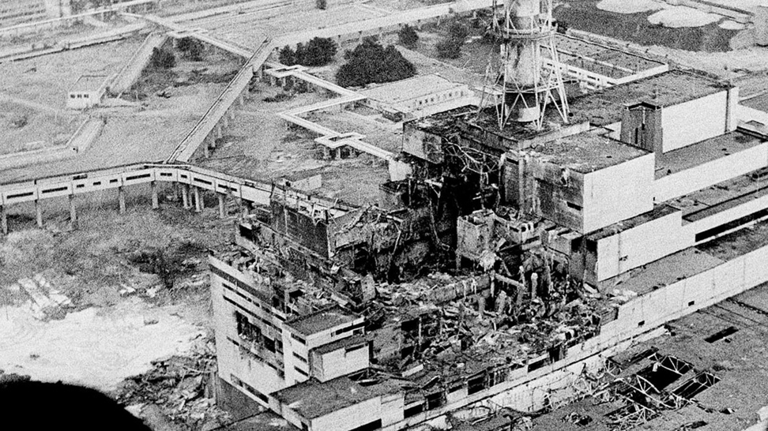
”Chernobyl Nuclear Power Plant, 26 April 1986 - A routine 20-second shut down of the system seemed to be another test of the electrical equipment. But seven seconds later, a surge created a chemical explosion that released nearly 520 dangerous radionuclides into the atmosphere. The force of the explosion spread contamination over large parts of the Soviet Union, now the territories of Belarus, Ukraine and Russia. According to official reports, thirty-one people died immediately and 600,000 “liquidators,” involved in fire-fighting and clean-up operations, were exposed to high doses of radiation. Based on the official reports, nearly 8,400,000 people in Belarus, Russia and Ukraine were exposed to the radiation, which is more than the population of Austria. About 155,000 sq. km of territories in the three countries were contaminated, which is almost half of the total territory of Italy. Agricultural areas covering nearly 52,000 sq. km, which is more than the size of Denmark, were contaminated with cesium-137 and strontium-90, with 30-year and 28-year half-lives respectively. Nearly 404,000 people were resettled, but millions continued to live in an environment where continued residual exposure created a range of adverse effects.

No reports were released until the third day after the Chernobyl explosion. Then, Swedish authorities correlated a map of enhanced radiation levels in Europe with wind direction and announced to the world that a nuclear accident had occurred somewhere in the Soviet Union. Before Sweden’s announcement, the Soviet authorities were conducting emergency fire-fighting and clean-up operations but had chosen not to report the accident or its scale in full. No established legitimate authority was able to immediately address the situation and provide answers to questions such as: Is it safe to leave the house? Is it safe to drink water? Is it safe to eat local produce? Communicating protective measures early would also have most likely enabled the population to escape exposure to some radionuclides, such as iodine 131, which are known to cause thyroid cancer. Early evacuation would have helped people avoid the area during the period when iodine 131 is most dangerous, 8-16 days after release.

During the first four years after the Chernobyl accident the Soviet authorities decided to largely deal with the consequences of the explosion at a national level. Without Soviet endorsement, the United Nations and its partners sought ways to provide emergency support, which included assessing the nuclear safety and environmental conditions of the contaminated area, and diagnosing the various medical conditions that resulted from the accident. The UN also focused on raising the awareness of the area’s inhabitants, teaching them how to protect themselves from radionuclides found in the environment and in agricultural products.

Many count the year 1990 as a crucial point in the United Nations' involvement in the Chernobyl recovery. The Soviet Government acknowledged the need for international assistance. As a result, the General Assembly adopted Resolution 45/190, which called for “international cooperation to address and mitigate the consequences at the Chernobyl nuclear power plant”. This Resolution also entrusted one of the Under-Secretary-Generals with the task of coordinating the Chernobyl co-operation and called for the formation of an Inter-Agency Task Force. The Quadripartite Coordination Committee, which consists of ministers from Belarus, Russia and Ukraine, as well as the United Nations Chernobyl Coordinator, became part of the coordination mechanism at the ministerial level. In 1992, a year after the Task Force was established, the Department of Humanitarian Affairs, which came to be called the Office for the Coordination of Humanitarian Affairs (OCHA) in 1997, began to coordinate international cooperation on Chernobyl. To expedite financial contributions towards the Chernobyl activities, the Chernobyl Trust Fund was established in 1991 under the management of OCHA. OCHA began to manage a range of diverse tasks and responsibilities from strategy formulation and promotion to resources mobilization, advocacy and channeling donors’ contributions. Since 1986, United Nations organizations and major Non-Governmental Organizations and Foundations have launched more than 230 different research and assistance projects in the fields of health, nuclear safety, including the construction of the Shelter, socio-psychological rehabilitation, economic rehabilitation, the environment, production of clean foods, and provision of information.
Over time it has become clear that the task of environmental and health recovery cannot be separated from the task of development. In 2001, UNDP, and its regional director for the three affected countries, became part of the coordination mechanism for Chernobyl cooperation. In the following year, the United Nations announced a shift in strategy, with a new focus on a long-term developmental approach, as opposed to emergency humanitarian assistance.
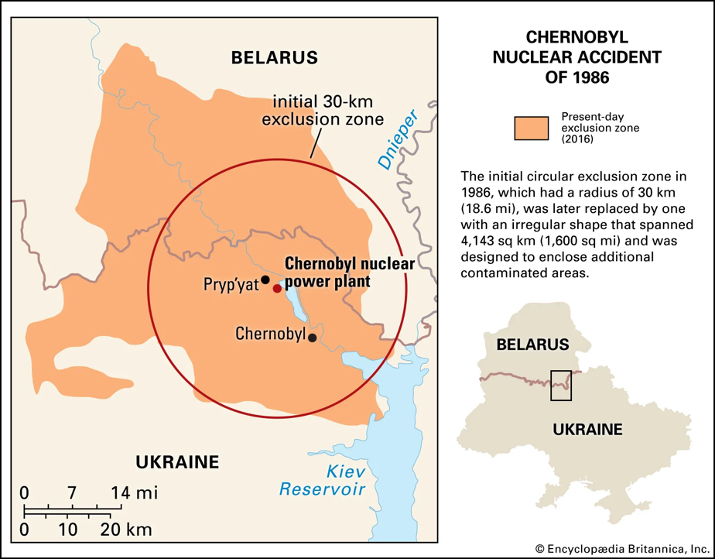
In 2004, the UN Secretary General transfered the coordination responsibility from UNOCHA to UNDP as part of a shift in strategy based on the 2002 study "The Human Consequences of the Chernobyl Nuclear Accident: A Strategy for Recovery". In the course of assuming coordination responsibilities, UNDP has identified three priority areas to pursue on Chernobyl:
- Information provision, including on promotion of healthy lifestyles;
- Community-based social and economic development;
- Policy advice, aimed at helping governments rationalize Chernobyl spending.
In order to clarify the remaining issues, and maintain worldwide attention on Chernobyl, the United Nations has undertaken a number of new initiatives. The Swiss-funded Chernobyl website Chernobyl.info serves as an independent forum on Chernobyl. The Chernobyl Forum, initiated by IAEA, is aimed at generating consensus on a range of disputed issues and reviewing all the scientific evidence on the impact of the Chernobyl accident on human health and the environment. GreenFacts summarises Chernobyl’s Legacy Report provided reassuring findings about the impact of low-dose radiation. They will be used by UNDP as source material in efforts to ease the fears of the affected populations and provide useful advice on how to live and work safely in the region. The International Chernobyl Research and Information Network (ICRIN), initiative launched by OCHA and the Swiss Agency for Development and Cooperation (SDC), is carried out by UNDP focusing on information dissemination to the Chernobyl-affected communities and popularizing healthy lifestyles. The first phase of ICRIN - information needs assessments - had already been completed by UNDP Country offices in Belarus, Russian Federation and Ukraine.”

  - Fukushima Daiici Accident (March 11, 2011)

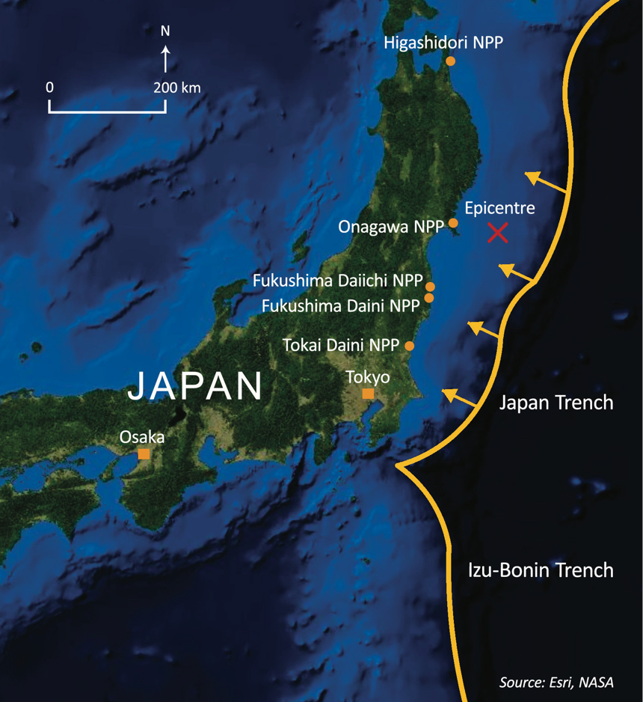
The Great East Japan Earthquake occurred on 11 March 2011 caused by a sudden release of energy at the interface where the Pacific tectonic plate forces its way under the North American tectonic plate, causing a massive earthquake with a magnitude of 9.0. The earthquake’s epicentre lay off the eastern coastline of Japan generating a tsunami which struck a wide area of coastal Japan, where several waves reached heights of more than ten metres. The earthquake and tsunami caused great loss of life and widespread devastation in Japan. At the Fukushima Daiichi nuclear power plant (NPP), the earthquake damaged the electric power supply lines and the tsunami caused substantial destruction of the operational and safety infrastructure on the site. The combined effect led to the loss of off-site and on-site electrical power. This resulted in the loss of the cooling function at the three operating reactor units as well as at the spent fuel pools. The four other NPPs along the coast were also affected to different degrees by the earthquake and tsunami. Despite the efforts of the operators at the Fukushima Daiichi NPP to maintain control, the reactor cores in Units 1–3 overheated, the nuclear fuel melted, and the three containment vessels were breached. Hydrogen was released from the reactor pressure vessels, leading to explosions inside the reactor buildings in Units 1, 3 and 4 that damaged structures and equipment and injured personnel. Radioactive materials were released from the plant to the atmosphere and were deposited on land and on the ocean. There were also direct releases into the sea.

- Relevant Information Regarding the Topic
  - Past Resolution Attempts

The IAEA has a programme (MSSPs) to support the member states for strengthening and sustaining the IAEAs’ nuclear verification capabilities by providing funds, equipment and access to the facilities since 1977. MSSPs effectively complement the work of the IAEA Department of Safeguards on their duty. Also MSSPs has beneficial effects to the members on collaboration and exchange with the IAEAs’ technical experts and partnership opportunities with other member states. Now there are only 24 member states in MSSPs’.

The IAEA had established a Global Nuclear Safety and Security Network (GNSSN) to share nuclear safety and security knowledge and services to further the goal of achieving worldwide implementation of a high level of nuclear safety and security.The Network is a key support element of the Global Nuclear Safety and Security Framework, which has the objective to achieve and maintain a high level of safety and security at nuclear facilities and activities around the world. The IAEA plays a central role in strengthening this Framework, by assisting Member States in building sustainable national competences and capabilities. It also promotes, through dedicated knowledge networks, the transfer of knowledge from countries with mature nuclear energy programmes to countries that have only just started to embark on such programmes.

The GNSSN, as a knowledge network, is part of an integrated IAEA methodology for capacity-building and contributes to enhancing international cooperation and dialogue in the field of nuclear safety and security, as well as harmonizing national approaches to nuclear safety knowledge management. Its main members are information providers and network operators.
The Network’s mission comprises three elements:
- Ensuring that relevant knowledge, experience and lessons learned related to nuclear safety and security are managed and shared for the benefit of Member States;
- Enabling and supporting interaction and collaboration between organizations and subject matter experts; and
- Establishing a capacity building framework to support the national nuclear safety and security infrastructure in IAEA Member States.
The GNSSN has public and restricted parts. While the public part provides access to open information sources, as well as relevant IAEA and external sources, the restricted site is used as a collaboration platform for safety and security teams, forums and user communities. It requires an official nomination and registration.

  - The Treaty on the Non-Proliferation of Nuclear Weapons (NPT)

The NPT basically is the agreement to ensure the peaceful usage of nuclear energy technologies to prevent the spread of nuclear weapons or weapons technology to achieve nuclear disarmament. The IAEA has a key role in NPT as the international safeguards inspectorate.

The NPT was opened for signature in 1968 and entered into force on 5 March 1970. On 11 May 1995, the Treaty was extended indefinitely. With 191 States parties, it is the most widely adhered to treaty in the field of nuclear non-proliferation, peaceful uses of nuclear energy and nuclear disarmament. Under the NPT, non-nuclear-weapon States parties have committed themselves not to manufacture or otherwise acquire nuclear weapons or other nuclear explosive devices while nuclear-weapon States parties have committed not to in any way assist, encourage or induce any non-nuclear-weapon State party to manufacture or otherwise acquire nuclear weapons or other nuclear explosive devices. Nuclear-weapon States parties under the Treaty are defined as those that manufactured and exploded a nuclear weapon or other nuclear explosive device before 1 January 1967. There are five nuclear-weapon States parties to the Treaty.
While the IAEA is not a party to the NPT, it is entrusted with key verification responsibilities under the Treaty. Each non-nuclear-weapon State party is required under Article III of the NPT to conclude a comprehensive safeguards agreement (CSA) with the IAEA to enable the IAEA to verify the fulfilment of their obligation under the Treaty with a view to preventing diversion of nuclear energy from peaceful uses to nuclear weapons or other nuclear explosive devices.
The IAEA therefore has a specific verification role as the international safeguards inspectorate, namely to verify the fulfilment of obligations assumed under the NPT by non-nuclear-weapon States parties. By 3 May 2023, 182 non-nuclear-weapon States parties to the Treaty have brought into force CSAs required by the Treaty and 4 of them have yet to do so.

Also IAEA serves as a multilateral channel for transferring peaceful applications of nuclear technology according to the NPT Article III and Article IV.
- NPT Article III: The IAEA administers international safeguards to verify that non-nuclear weapon States party to the NPT fulfil the non-proliferation commitment they have made, “with a view to preventing diversion of nuclear energy from peaceful uses to nuclear weapon or other nuclear explosive devices.”
- NPT Article IV: The IAEA facilitates and provides a channel for endeavours aimed at “the further development of the applications of nuclear energy for peaceful purposes, especially in the territories of non-nuclear-weapon States Party to the Treaty, with due consideration for the needs of the developing areas of the world.”

Under Article III of the NPT, each non-nuclear-weapon State party undertakes the obligation to conclude a comprehensive safeguards agreement with the IAEA. Under such agreement, the IAEA has the right and obligation to ensure that safeguards are applied on all nuclear material in all peaceful nuclear activities within the territory of the State, under its jurisdiction or carried out under its control anywhere, for the exclusive purpose of verifying that such material is not diverted to nuclear weapons or other nuclear explosive devices.

  - The Convention on the Nuclear Safety (CNS)

The Convention on Nuclear Safety (CNS) is based on the Parties' shared interest to achieve higher levels of safety that will be developed and promoted through regular meetings. It requires Parties to submit reports on the implementation of their obligations for "peer review" at meetings. The goal of the Convention is to commit Contracting Parties operating land-based civil nuclear power plants to maintain a high level of safety by establishing fundamental safety principles to which States would subscribe.

The objectives of this convention as stated in the document are:
- to achieve and maintain a high level of nuclear safety worldwide through the enhancement of national measures and international co-operation including, where appropriate, safety-related technical co-operation;
- to establish and maintain effective defences in nuclear installations against potential radiological hazards in order to protect individuals, society and the environment from harmful effects of ionizing radiation from such installations;
- to prevent accidents with radiological consequences and to mitigate such consequences should they occur.
The CNS has obligations to the Contracting Parties. Those are:
- Each Contracting Party shall take, within the framework of its national law, the legislative, regulatory and administrative measures and other steps necessary for implementing its obligations under this Convention.
- Establishment of applicable national safety requirements and regulations,
- Each Contracting Party shall establish and maintain a legislative and regulatory framework to govern the safety of nuclear installations.
- Each Contracting party shall ensure that each licence holder meets their responsibility.
There are more obligations for Contracting Parties in the CNS to achieve the objectives and nuclear safety.

  - Safety standards established by the IAEA

The very first Nuclear Power Plant (NPP) was established in Moscow, and since then, scientists and governments have been aware of the risks of NPPs. Due to the high nuclear energy capacity of these plants, the IAEA got into action to regulate international safety standards for governments that want to operate their own NPPs to prevent possible catastrophic incidents. These safety standards and regulations tightened after the Chernobyl Disaster.

Establishing or adopting safety standards for the protection of health and to minimize the danger to life and property is authorized by the IAEA's statute, which also requires the Agency to promote international cooperation. The Agency develops these standards based on an open and transparent process for gathering, integrating, and sharing knowledge and experience gained from the use of technologies and from the application of the Safety Standards themselves.

Under the terms of Article III of its Statute, the IAEA is authorized to establish or adopt standards of safety for protection of health and minimization of danger to life and property, and to provide for the application of these standards.

The publications by means of which the IAEA establishes standards are issued in the IAEA Safety Standards Series. This series covers nuclear safety, radiation safety, transport safety and waste safety, and also general safety (i.e. all these areas of safety). The publication categories in the series are Safety Fundamentals, Safety Requirements and Safety Guides.
Safety standards are coded according to their coverage: nuclear safety (NS), radiation safety (RS), transport safety (TS), waste safety (WS) and general safety (GS).

The Safety Standards consists of three sets of publications: the Safety Fundamentals, the Safety Requirements and the Safety Guides. While the first one of these establishes the fundamental safety objective and principles of protection and safety, the second set out the requirements that must be met to ensure the protection of people and the environment, both now and in the future. The Safety Guides provide recommendations and guidance on how to comply with the requirements.

The IAEA has established a wide-range of documentation series to clarify the safety standards. The Contracting Parties and Governments need to implement those rules to their Nuclear Power Plants. The main documentation is “Fundamental Safety Standards (2006)” and the other documents complete that main document like stated at the IAEA’s Safety Standards Wheel.

- Bibliography

Char, N. L., & Csik, B. J. (1987). Nuclear power development: History and outlook. IAEA bulletin, 3, 1987.
CONVENTION ON NUCLEAR SAFETY. (n.d.). International Atomic Energy Agency Information Circular. Retrieved July 5, 1994, from https://www.iaea.org/sites/default/files/infcirc449.pdf
Introductory Webinar on the IAEA Safety Standards “Remediation Strategy and Process for Areas Affected by Past Activities or Events” and “Leadership, Management and Culture for Safety in Radioactive Waste Management.” (n.d.). IAEA. https://www.iaea.org/resources/webinar/introductory-webinar-on-the-iaea-safety-standards-remediation-strategy-and-process-for-areas-affected-by-past-activities-or-events-and-leadership-management-and-culture-for-safety-in-radioactive-waste-management
Member States Support Programmes. (n.d.). IAEA. https://www.iaea.org/topics/safeguards-and-verification/programmes/member-states-support-programmes
Safeguards legal framework. (n.d.). IAEA. https://www.iaea.org/topics/safeguards-legal-framework
Safeguards explained. (n.d.). https://www.iaea.org/topics/safeguards-explained
Basics of IAEA Safeguards. (n.d.). IAEA. https://www.iaea.org/topics/basics-of-iaea-safeguards
Safeguards and verification. (n.d.). IAEA. https://www.iaea.org/topics/safeguards-and-verification
Safeguards implementation. (n.d.). IAEA. https://www.iaea.org/topics/safeguards-implementation
Treaty on the Non-Proliferation of Nuclear Weapons (NPT) – UNODA. (n.d.). https://disarmament.unoda.org/wmd/nuclear/npt/#:~:text=The%20NPT%20is%20a%20landmark,and%20general%20and%20complete%20disarmament.
Review Conference of the Parties to the Treaty on Non-Proliferation of Nuclear Weapons. (n.d.). In The International Atomic Energy Agency. United Nations. Retrieved March 17, 2024, from https://www.un.org/en/conf/npt/2015/pdf/IAEA%20factsheet.pdf
The IAEA and the Non-Proliferation Treaty. (n.d.). https://www.iaea.org/topics/non-proliferation-treaty
World Nuclear Association. (n.d.). https://web.archive.org/web/20110330222020/http:/www.world-nuclear-university.org/about.aspx?id=8674&terms=atoms%20for%20peace
IAEA Safety Standards for Protecting People and the Environment. (2006). In Fundamental Safety Principles. International Atomic Energy Agency. Retrieved March 17, 2024, from https://www-pub.iaea.org/MTCD/Publications/PDF/Pub1273_web.pdf
Safety standards. (n.d.). IAEA. https://www.iaea.org/resources/safety-standards
Nuclear Power Today | Nuclear Energy - World Nuclear Association. (n.d.). https://world-nuclear.org/information-library/current-and-future-generation/nuclear-power-in-the-world-today.aspx#:~:text=Nuclear%20energy%20now%20provides%20about,of%20the%20total%20in%202020)
nuclear accident. (n.d.). https://www.eionet.europa.eu/gemet/en/concept/5708
Home | West Bengal Disaster Management & Civil Defence Department. (n.d.). http://wbdmd.gov.in/pages/Nuclear2.aspx
The 1986 Chornobyl nuclear power plant accident. (n.d.). IAEA. https://www.iaea.org/topics/chornobyl
Frequently Asked Chernobyl Questions. (n.d.). IAEA. https://www.iaea.org/newscenter/focus/chernobyl/faqs
The Kyshtym accident, 29th September 1957. (n.d.). NRPABulletin. http://large.stanford.edu/courses/2017/ph241/buttinger1/docs/NRPA.pdf
Lessons From the 1979 Accident at Three Mile Island. (2019, October 1). Nuclear Energy Institute. https://www.nei.org/resources/fact-sheets/lessons-from-1979-accident-at-three-mile-island
The Fukushima Daiichi Accident. (2014, December). International Atomic Energy Agency. Retrieved March 17, 2024, from https://www.iaea.org/sites/default/files/fr-brochure.pdf
Safety and security culture. (n.d.). https://www.iaea.org/topics/safety-and-security-culture
IAEA Safeguards Serving Nuclear Non-Proliferation. (2015, June). International Atomic Energy Agency. Retrieved March 17, 2024, from https://www.iaea.org/sites/default/files/safeguards_web_june_2015_1.pdf
The IAEA and the Non-Proliferation Treaty. (n.d.). https://www.iaea.org/topics/non-proliferation-treaty
Accidents at Nuclear Power Plants and Cancer Risk. (2022, May 12). National Cancer Institute. https://www.cancer.gov/about-cancer/causes-prevention/risk/radiation/nuclear-accidents-fact-sheet#:~:text=At%20high%20doses%2C%20ionizing%20radiation,cataracts%2C%20as%20well%20as%20cancer.
DELAYED HEALTH EFFECTS OF EXPOSURE TO THE 1957 KYSHTYM NUCLEAR ACCIDENT: EXPOSED PERSONS AND THEIR OFFSPRING. (n.d.). Retrieved March 17, 2024, from https://inis.iaea.org/collection/NCLCollectionStore/_Public/28/012/28012932.pdf

